LISTA 16

Roberta Cristina de abreu 4°ADS

1)

Máquina 1:

su

Apt install apache2 libapache2-mod-php7.0 php7.0 phpmyadmin

Groupadd web

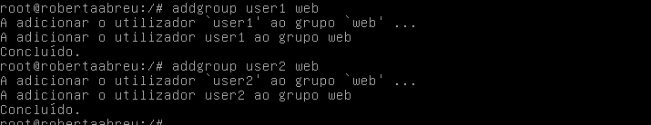

Chown –R root:web /var/www/html -R

Chmod 770 /var/www/html -R

Máquina 2:

Su

Apt install mariadb-client mariadb-server

Groupadd web

Addgroup user1 web

Addgroup user2 web

Mysql –u root –p

> create database webdb01 charset utf8;

> create user 'webdbuser01'@'localhost' identified by 'p@ssword123';

> grant all privileges on webdb01.\* to 'webdbuser01'@'localhost' with grant option;

> flush privileges;

Nano /etc/mysql/mariadb.conf.d/50-server.cnf

Servisse mariadb restart